Marker

UCI UNDERGRAD

**Megan Le |** Business Economics, Minor in Innovation

**Mirna Elaasar |** Business Administration, Bio Sci

**Ryan Walsh |** Computer Science

**Micah Raney |** Electrical Engineering

**Richard Hsu |** Computer Science

**Freniel Zabala |** Computer Science

**Lockers**

**O**

**T**

**O**

**G**

GOTO Lockers is an advanced, high-tech locker system with built-in digital screens that offers a solution to a multi-faceted problem faced by college campuses. First, the demanding schedule of a typical college student leads them to carry many items including books, work uniforms, lunchboxes and skateboards which is tremendously burdensome. With GOTO Locker systems placed at frequented locations around campus, a student has a safe space to store their belongings everywhere they go. Secondly, campus organizations and outside businesses struggle with targeting students at the right time. GOTO Lockers’ digital screens will dynamically cycle advertisements to increase market penetration as compared to current advertising methods. Third and most importantly, our system will keep campuses safe by allowing emergency alerts to be posted anytime and providing real time video streams for campus security.

Projected revenue

*per campus* where GOTO Lockers is implemented.

Approx. 1400 4-year colleges according to the U.S. News & World Report.

**Market and Customers**

**$1.6 mil**

**Our Progress**

The multi-faceted customer problem inspired our team to create a high-tech solution with a wide market and customer base.

**Our Opportunity**

Our major hardware and software components are clearly defined; system requirement spec is 80% complete. Domain name gotolockers.com was registered and prototype parts were purchased and tested with demo code. We are in the midst of discussing plans with UCI personnel and collaborating with organizations and businesses to promote advertisement opportunities.

100%

50%

53%

54%

67%

**College Students:** Need a safe space to store personal belongings temporarily amid their busy school schedule.

**Campus Security:** Need the ability to interfere with screens to display emergency alerts or access built-in surveillance cameras.

**Campus Organizations:** Need a platform to advertise and display campaigns, a more effective way to extend their reach.

**Local and National Businesses:** Need a platform to promote business deals or specials tailored to students.

*Including: ASUCI, International Center, Improv Revolution, Undergraduate Finance Association*

**1**

Market survey was conducted at UCI as a proof of concept. Findings are applicable to other college campuses. Our goal with this competition funding is to successfully start GOTO Lockers at one college campus and then scale it nationwide.

Of the 211 students* surveyed …

Of the 10 campus clubs surveyed …

Wish there were was a more effective way to advertise

Said they would use the service if existent

Say they would use a safe storage space if one was provided

Spend 7+ hours daily on campus

Would say amount or weight they carry is inconvenient

**Overview**

**2**

**4**

**1q**

**3**

**3**



**Gotolockers.com** for **Ad Customers**:

**GOTO App** for **students**:

1. Register and verify account
   1. Provide: School ID & Email and CA License/US Passport
2. View campus map displaying user’s location and closest available locker system to them on campus.
3. Reserve locker of choice.
4. Unlock and lock locker through app.



**Product Description**

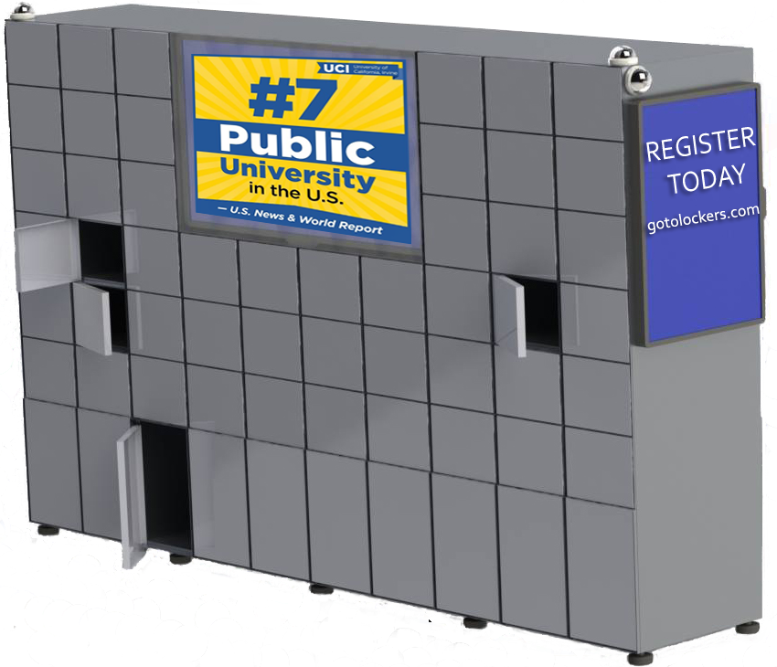

*Each locker system consists of:*

* **58** compartments:
  + **48** square-sized compartments
    - (1 ft (w) x 9 in(h) x 1.5 ft (d))
  + **10** large bottom row compartments
    - (1 ft (w) x 18 in (h) x 1.5 ft (d))
* **1** front-facing central horizontal screen
* **2** side vertical screens
* **4** security cameras
* A built-in non-interruptible power-supply in case of power outage

10 ft

2 ft

**Locker Specs**

**Locker System Network Configuration**

Each locker system is connected to an integrated Wi-Fi network allowing students to lock and unlock their locker compartment through the GOTO app. Additionally, every locker system will have an embedded computer that will frequently run a program to grab advertisements submitted by companies through our website. This will ensure that the screens are continuously updated with new advertisements as requested by different campus clubs and businesses.

GOTO Lockers will be the first in this market. The closest competitor is a company named Gantner that retrofits existing locks on doors, lockers, etc., to electronic locks. Amazon lockers and other kiosks exist for package delivery purposes and storage for theme parks or ski resorts, but GOTO Lockers the first integrated system targeting college campuses to keep them safe and convenient for all.

**Vertical Side Screen**

**(1K 32” monitor)**

**Central Screen (4K 50” monitor)**

**Competitors**

**Large bottom-row compartments**

**Raised legs to prevent any water damage to bottom compartments**

**Square-sized compartment**

8 ft

1. New user creates an account on gotolockers.com.
2. Post ad details and upload files.
3. Administrators will approve ad content.
4. FTP server support and our program will transfer ads to the GOTO Lockers screens to chosen locations around campus.

*Quantity and placement of lockers on campus will be determined with consideration to the density of student activity, location of academic units, and location demand.

* One front screen has 6 ads in rotation per minute (10 second slots per ad)
* Two side screens display one static ad each
* Every ad costs $15 per week and $55 per month

**$125K**

**Ad-Use Revenue Forecast**

**Locker-Use Revenue Forecast**

* Hour 1 is Free
* Hours 2,3,4 is $1.00/hr for a total of $3
* Hour 7 – Hour 23 are free
* Daily cost is $3.
* Membership $10 per week or $50 per quarter

**Revenue and Cost Model**

Potential for weekly ad subscription: $15/ad * 8 ads total x 52 weeks/yr x 20 locker systems

Potential for monthly ad subscription: $55/ad * 8 ads total x 12 months/yr x 20 locker systems

**$106K**

**$600K**

**$1.2M**

**$174K**

Potential for daily locker-use: 58 compartments x $3/day x 365 days/yr x 20 locker systems

Potential for weekly membership: 58 compartments x $10/week x 52 weeks x 20 locker systems

Potential for monthly membership: 58 locker compartments x $50/quarter x 3 quarters x 20 locker systems

**Meet the Team**

*Our project is fully staffed with team members of the right skill mix.*

*We are ready* ***to go*** *with* ***GOTO Lockers****!*

**Megan, Project Lead**

Experience: Megan has worked as a Business Intern (17-’18) at Corporate of St. Jude Hospital and is an incoming intern at Northrop Grumman (’19).

**Mirna, Business Coordinator**

Experience: Mirna is a part of the Student Managed Investment Club at UCI and has interned in Egypt adopting technical skills like R, Tableau and Python.

**Ryan, Engineering Lead**

Experience: Ryan has designed multiple database schema to make reports for laboratories across the globe from Siemen’s Atellica Solution.

**Micah, Mechanical Engineer**

Experience: Micah has designed and fabricated robotic mechanisms for various projects through Zotbotics as well as electrical circuit and PCB design and verification through UCI CubeSat.

**Richard, Software Engineer**

Experience: Richard has taken part in LAHacks 2018 where he developed an Android app using LA City data APIs to guide users to nearest and cheapest parking lot.

**Freniel, Network Architect**

Experience: Freniel has worked as a full stack developer Intern at Academic Web Technologies (AWT) in 2018. He also was a front-end developer for HackUCI 2019.